**Project Synopsis**

**Title/Proposed Topic:** Cellular IoT enabled smart-farm management system.

**Name of Student and Team Details:**

1. Aiyaz Ahmed N. Hansbhanvi. (201104003)
2. Atmanand Gauns. (201104012)
3. Mulla Aizaz Muzawar. (201104034)
4. Ramesh Dinesh Pai. (201104047)
5. Sahil Sharfuddin Shaikh. (201104060)

**Branch**: Electronics and Telecommunication

**Name of the Internal Guide**:

**Venue:** GEC/Industry

**Name of the External Guide (for Industry Projects):**

**Problem Statement:**

Modern agriculture faces challenges such as data utilization, real-time monitoring, and

predictive analysis. AgroLink addresses these issues by creating a connected ecosystem for smarter farming.

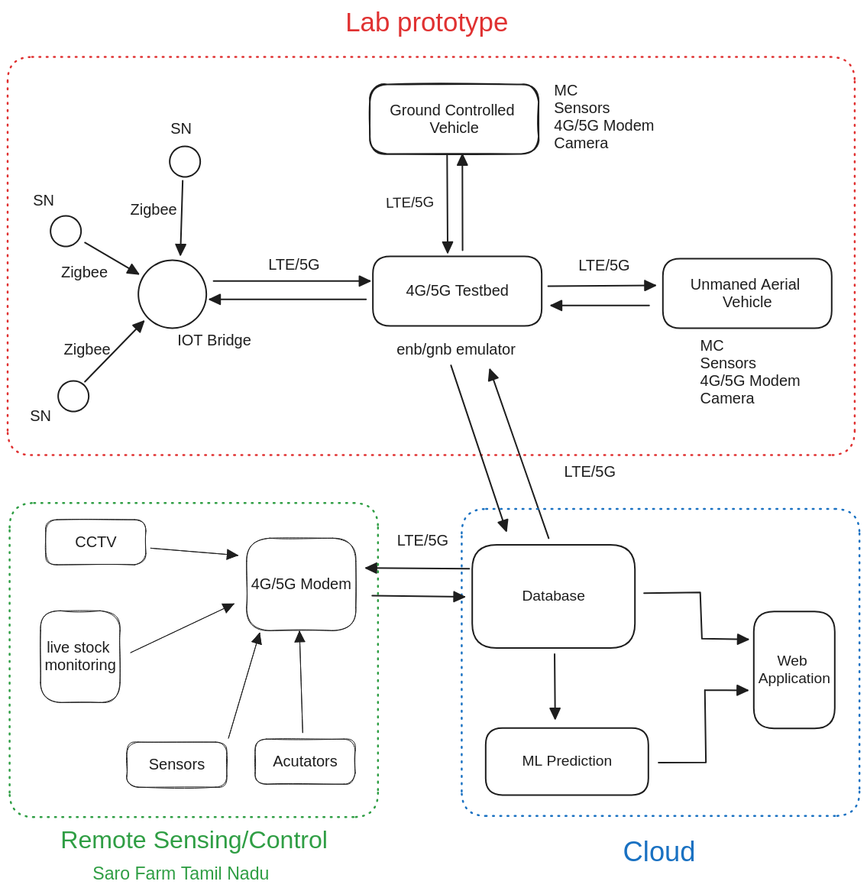**Block Diagram:**

**Software Tools/Hardware Specification:**

* IoT Sensors: [Sensor Models]
* Database: [Database Software]
* Web Application: [Web Framework]
* Cloud Integration: [Cloud Service Provider]
* Machine Learning: [ML Framework]
* Connectivity: LTE/5G

**Synopsis:**

AgroLink, an innovative agricultural project, aims to transform traditional farming into a

leverages IoT sensors, machine learning, cloud integration, and web applications to create a

holistic ecosystem that empowers farmers with real-time insights, predictive analysis, and

efficient decision-making.

The project envisions an interconnected setup called "The Farm," where IoT sensors collect

data on various parameters such as soil moisture, weather conditions, and crop health. This

data is seamlessly integrated into a central database, creating a repository for historical and

real-time information.

AgroLink's crown jewel is its ML Prediction module, which employs machine learning

algorithms to forecast trends, enabling farmers to make informed choices. The "Web

Application" interface acts as a window into this data-rich world, presenting users with

intuitive visualizations and predictive graphs.

To ensure scalability and resilience, AgroLink embraces cloud technology. By harnessing the

power of the cloud, the system maintains robust performance even during peak usage.

In summary, AgroLink stands as a testament to the potential of technology in agriculture. It

aspires to bridge the gap between traditional practices and modern innovation, making

farming not only productive but also sustainable and future-ready. With AgroLink, the future

of agriculture begins today.

**Title/Proposed Topic:** Cellular IoT enabled smart-farm management